Capstone project – final presentation

Vaibhav Pawade for Coursera Capstone Project

Introduction and Business Problem

- A customer, Jerónimo, wants to open a new burger joint in Bogotá, Colombia.

- Due to Bogotá’s high diversity and very large size, he asked me for help in order to find the best spot to place the burger joint.

- Bogotá has 20 different Localities (Districts) and we aim to find the best one.

- We need to choose a Locality that has good amount of customers and low amount of competition.

Data

- To help Jeronimo in his search we will need to access following data:

- The Localities of Bogotá, Colombia from Wikipedia: https://es.wikipedia.org/wiki/Anexo:Localidades_de_Bogot%C3%A1

- The coordinates (latitude, longitude) ot these Localities of Bogotá from Open Street Map APIs

- From Foursquare we will need following venues data:

  - the burger joint venues of the Localities

  - the offices venues of the Localities

  - the high schools venues of the Localities

  - the universities venues of the Localities

- We will then leverage the data in order to determine which locality is the most appropriate in order to locate the burger joint.

Methodology

- For each locality, all office, school, university and burger joints venues data have been collected from Foursquare.

- Then for each locality, the sums of the office, school, university and burger joints were computed.

- For each of this 4 categories, a weight (or penalty) has been defined according to what Jeronimo considers the most important.
  - Burger Joints have been weighted with -1, since Paolo wants to avoid concurrence.

  - Schools have been weighted with 1, since student are good customers.

  - Universities have been weighted with 1.5, since students are good customers.

  - Offices have been weighted with 2, since employees are even better customers.

- Note that the weights can be modified according to the importance of each category.

- Lastly, a score was computed for each locality as the weighted sum of the number of venues in each of the 4 categories (school, university, office, burger joints).

Localities of Bogotá, Colombia
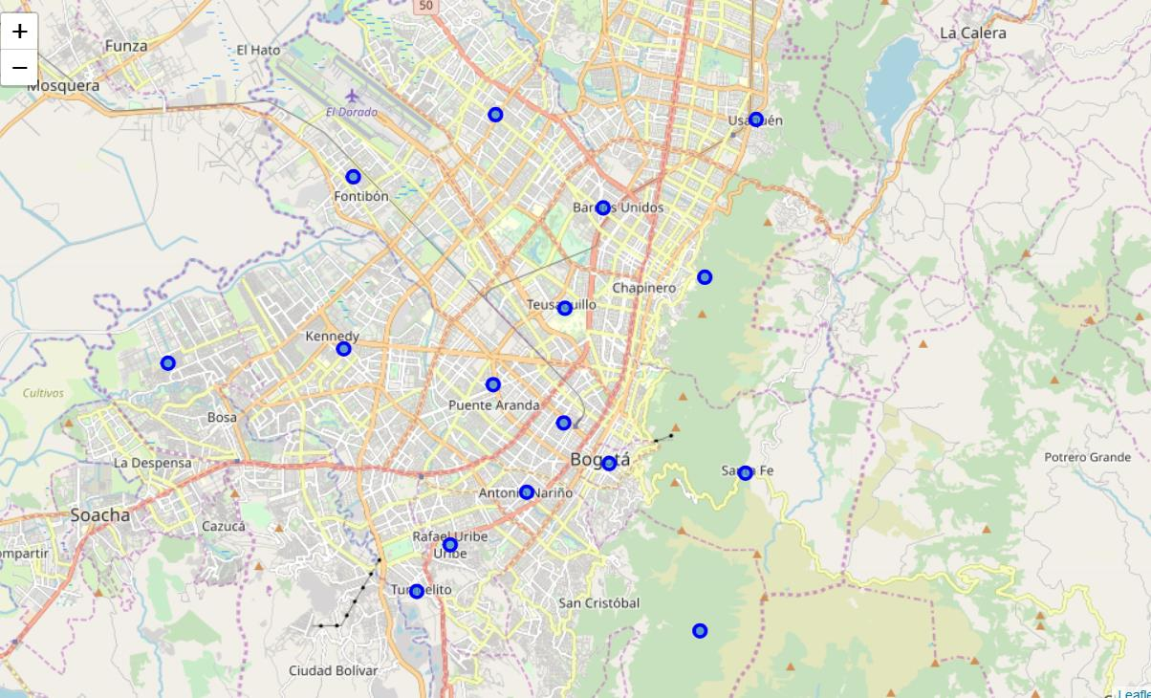
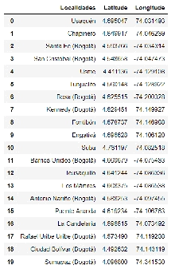
Burger Joints in Bogotá Localities
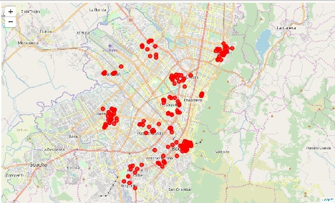

High Schools in Bogotá Localities
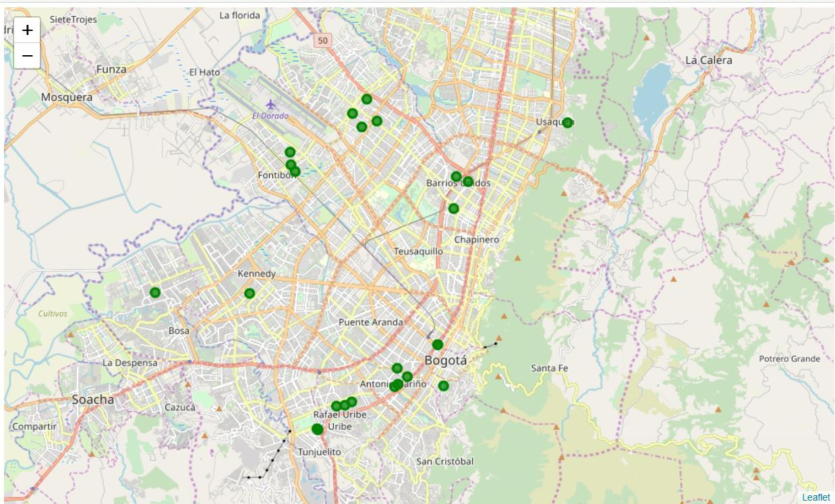
Universities in Bogotá Localities
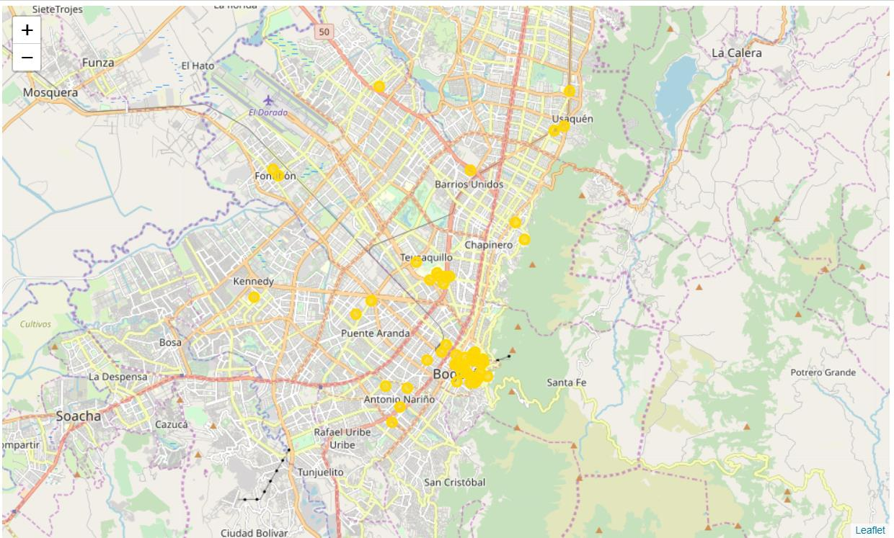

Offices in Bogotá Localities
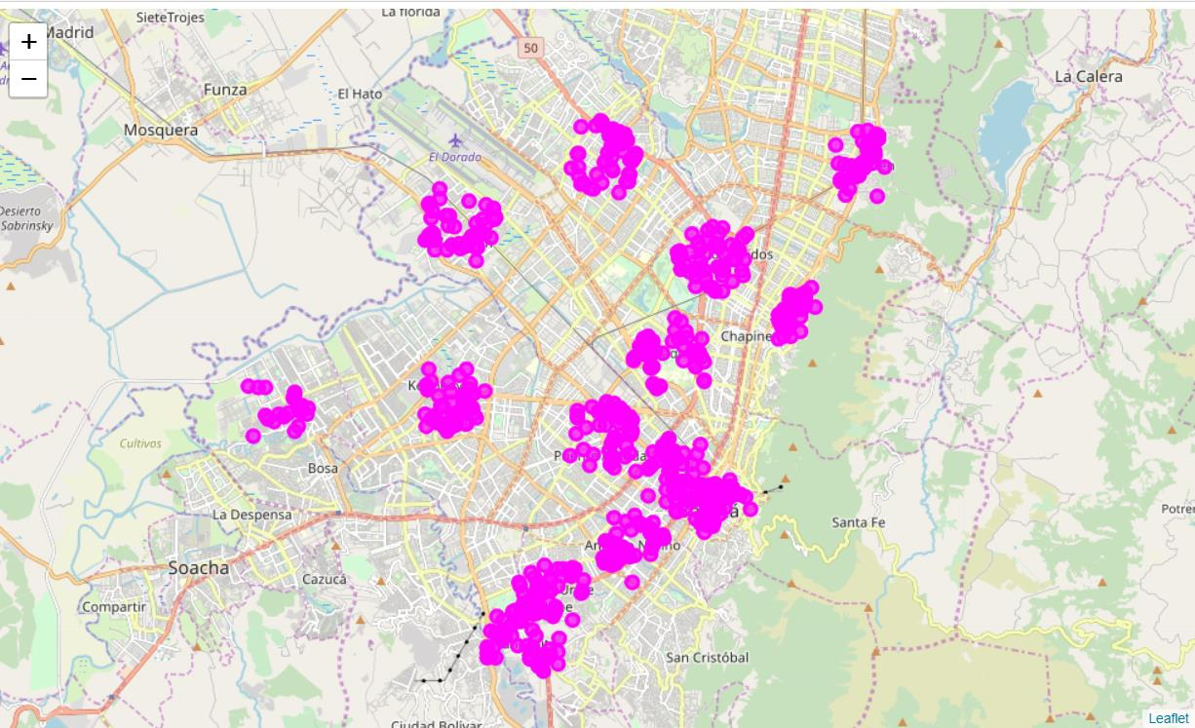
Results
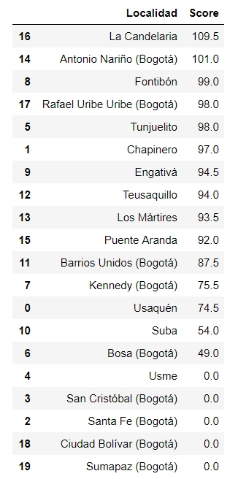

- The Locality with the best score is “La Candelaria” with 109.5, being the best option.

- Follows closely “Antonio Nariño” with 101.

These options maximizes the number of potential customers from offices and universities and at the same time have not too large competence.
Best Place for the Burger Joint in Bogotá is “La Candelaria”
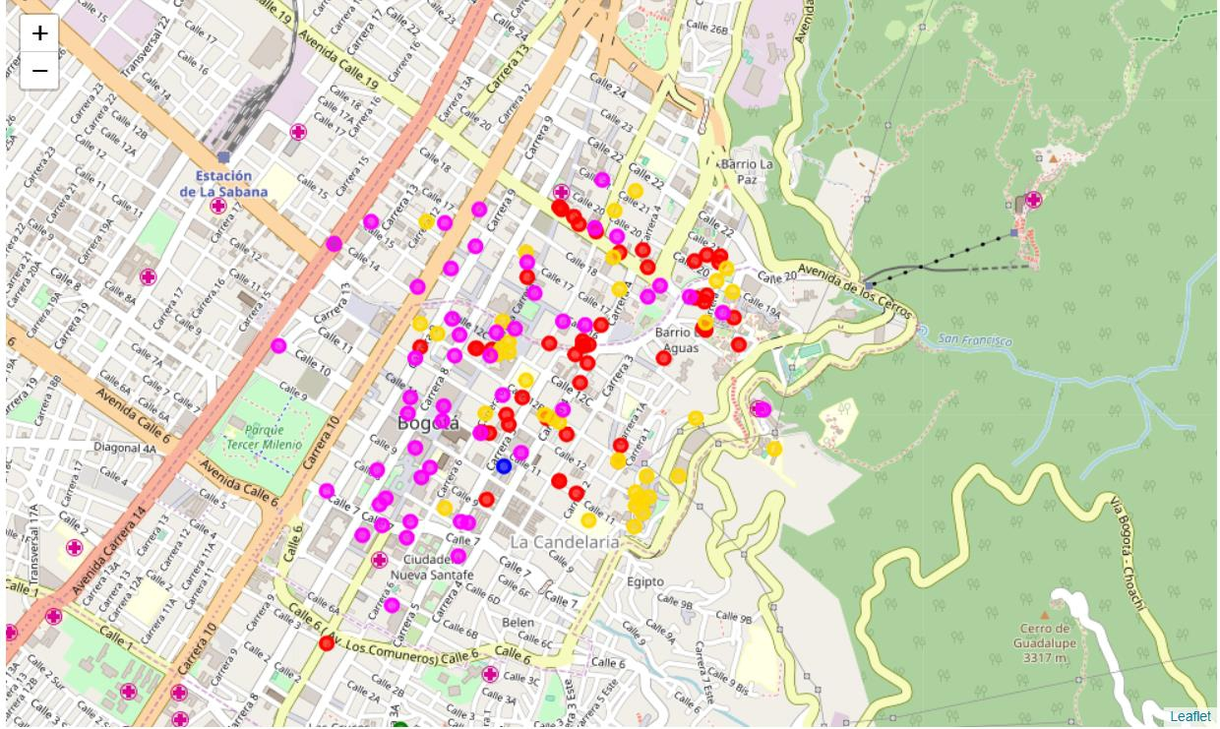

Recommendation

The following analysis can be improved with following extensions:

- Consider more categories. For example like "Night life" which is also a good source for customers. But also like "Restaurants", which even if not burger joints may be some concurrence if too many.

- In the Locality itself, it can also be computed the distance between all the venues in order to find a place with the most number of potential customers.

- Using smaller geographical areas like Neighborhoods could improve the accuracy for the scores.

